CS 420

Project 1

Ksenia Burova

February 8th, 2017

**Classification of 1D Cellular Automata**

**Project Report**

**Abstract:**

In current project report, the task was to explore “Edge of Chaos” phenomena or Wolfram class IV behavior in 1D Cellular Automata (CA). The goal was to run several experiments. At each experiment, random rule table (string) was generated. Rule string had to be decimated (zeroing one entry) until completely zeroed producing fixed number of steps for each experiment. At each step, simulation was run generating images of CA behavior. Next exercise was to observe patterns formed by CA, to classify them, and to calculate Langston’s Lambda and Entropy parameters. From retrieved data 4 graphs were built and analysis was done, explaining correlation between parameter values and the class IV behavior.

**Question:**

Draw conclusions about the range of values of $λ, λ_{T}, H, H_{T}$ that lead to class IV behavior.

1. Are there any anomalies like:
   1. Class I or II at high parameters values?
   2. Any class III or IV behavior in I,II region?
2. Any other correlations between the parameter values and the class behavior ?

**Variables:**

Number of experiments = 40

Radius of cell’s relevant neighborhood, r = 1

Number of states, k = 5

0 – pink

1 – blue

2 – green

3 – yellow

4 – red

Seed for random string generation = -8999515360070250000

**Discussion:**

**Class I** observations and anomalies:

For the majority of the experiments, class I was observed after decimation of about a half of the rule string. There were interesting moments, where class I could be observed at the very first step. For example, Pic. 1 demonstrates Class I behavior before rule string was decimated at all with $λ= 0.992$. Pic. 2 demonstrates class 1 as well after a single decimation with $λ=0.968$.

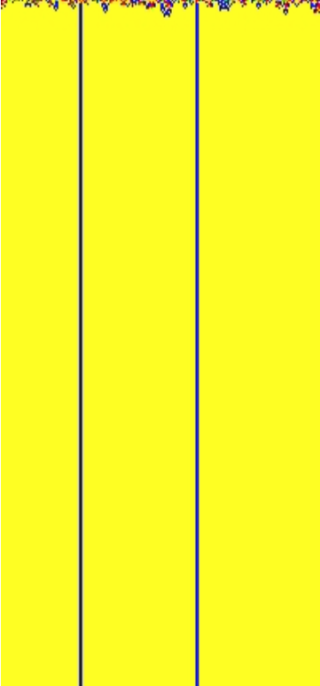

Pic. 2. Experiment 7, Step 1. Class I

Pic. 1. Experiment 4, Step 0. Class I

The whole Experiment 12 demonstrated a behavior, where 1st 6 and last 4 steps of decimation were class I ( Pic 3.)

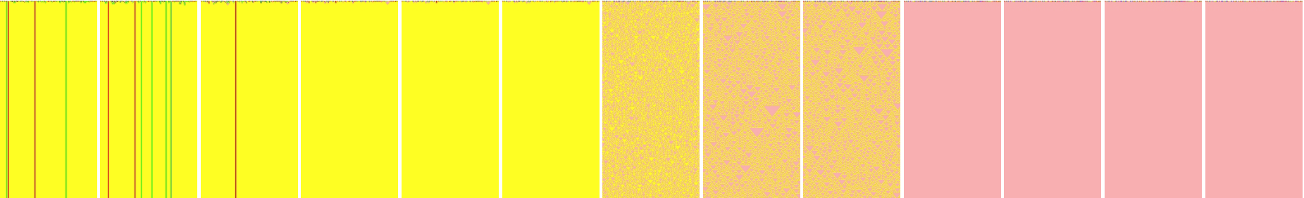

Pic. 3. Experiment 12 Class I mostly + Class III

According to Langton, $λ$ value for class I should go up to ~ 0.3, in many of these experiments, $λ$ was going up to ~0.4, there were examples of it to be 0.6-0.7. And of course, examples above are the most extreme.

It is very hard to explain such behavior. Entropy values differ for all, lambda values are around 0.9. For Pic. 1, rule table was 443314333142, for Pic. 2, it was 211314142404, for Pic. 3, starting rule string was 243323233342. The only thing that is noticeable here is that all strings have a state value that is listed 1 or 0 times. On 3rd one, “1” is missing, for example, 1st has “2” once, 2nd has “3” once. It’s hard to tell though if that observation is what this behavior is correlated to in this anomaly. Also, Langton’s study it states that such behavior is possible when most of the rules map to the same non-quiescent state. Highlighted areas in strings show haw many of those were same (for relevant color state).

**Class II** observations and anomalies:

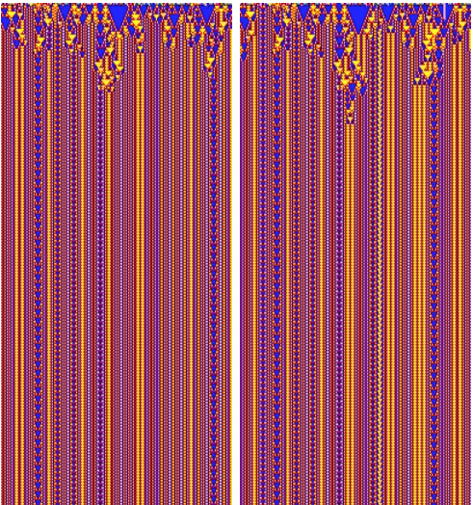Observations of class II were very similar to class I. Langton’s $λ$ average is ~0.43. In this project, there were instances with values ~ 0.25 – 0.99. The most popular values were ~0.5 - 0.6. There were not that many instances of Class II among the whole project run. Pic. 4 and Pic. 5 demonstrate Class II periodic behavior at $λ=0.992$, which is very unusual for Class II.

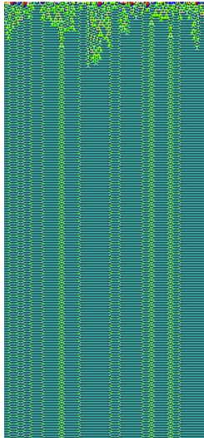

Pic. 5. Experiment 11 step 0 and 1. Class II

Pic. 4. Experiment 4, step 0. Class II

The most interesting examples of Class II were in Experiments 30 and 35. In experiment 30 step 10 (Pic. 6), pattern seems to remind of class III, indeed, 1 step before it was class III with same colors and structure. $λ$ = 0.048 there, which is also too low for Class II usually. You can definitely see repetition in this example.

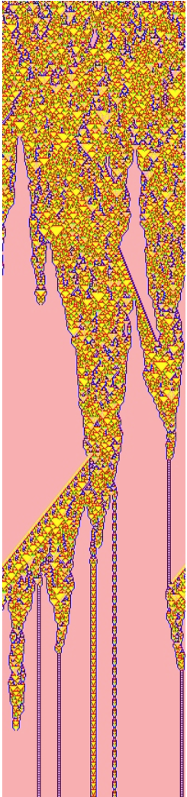In experiment 35 step 2, (Pic. 7), there is a very very long transient period. It seems to remind Class IV structure at first, but only we care about the end of the structure, and there it becomes completely periodic.

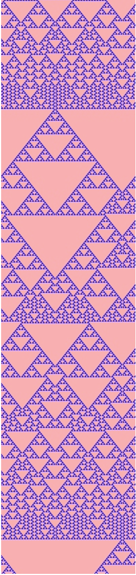

Pic. 6. Experiment 30, step 10. Class II

Pic. 7. Experiment 35, step 2. Class II

It is also hard to explain inconsistent behavior of class II, but there is the same things applied to it as for class I about mapping states in rule table.

**Class III** observations and anomalies:

Class III was also very interesting to observe. According to Langton, $λ$ average for Class III is ~0.82. $λ$ for Class III in this project had values ~0.024 – 0.99. That is very broad. The most popular value resides near 0.8-0.9. All patterns in Class 3 were very chaotic. There were ones reminding of the “white noise”, the ones with a bunch of triangle structures of different sizes (gliders) . There were couple of images, where Class III would have some elements from Class II.

The best example, that describes how inconsistent $λ$ for class III, would be experiment 27, where all steps but last one produces class III (Pic. 8).

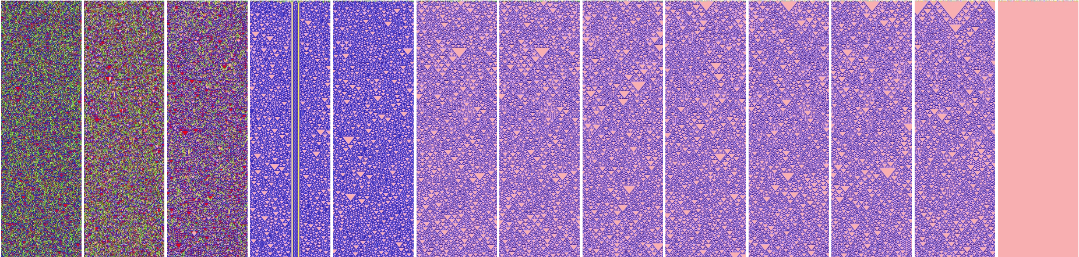

Pic. 8. Experiment 27. Class III mostly

There is also that time in step 3 (0 indexed), when class 2 structure is laying on a top of chaotic pattern. This is a great example to show how entropy value may differ for class III.

First 2 steps indicate H = ~1.8, for next two H = ~ 1.94. Indeed, they have a pretty much equal amount of each state in image, although striped image consists of only 2 states. Totalistic H numbers match results better here. The last H value (step 11) is 0.16, meaning that out of 5 states 1 dominate and that’s how it is.

The great image of pure Class III with high $H =2.13$ and $H_{t}=2.2$ is below on Pic. 9.

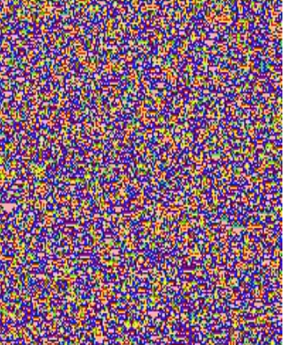

Pic. 9. Experiment 13 Step 3. Class III Chaos

There were many instances where it was extremely hard to explain which class behavior was observed, III or IV. In attached Excel Document they will be marked as “3/4”.

**Class IV** observations and anomalies:

Class IV was the most complicated. Sometimes it is not very clear if behavior corresponded to Class IV or III. Class IV behavior is very complex. From Langton’s study, $λ$ value should be about ~0.5 which is somewhere in between the ones specific for Classes II and III.

The table on Pic. 10 has all instances of Class IV listed with all the parameters (table can be found in attached excel work sheet) .

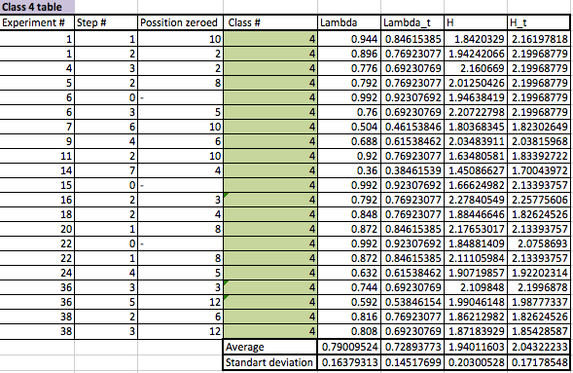

Pic. 10. Table of class 4 instances. Average and Standard Deviation Calculations of all parameters

This experiment showed that for 40 experiments and 12 steps in each there are only a few instances of class IV behavior (“3/4” are not listed here). The average $λ$ is 0.79 and totalistic one is 0.72. It is higher than in Langton’s study, but $λ$ was also higher than average for other 3 classes as well. So, its value is somewhere in between classes II and III. As it was stated above, class II was mostly found with $λ=\sim 0.5-0.6$ and Class III was mostly found with $λ=\sim 0.8-0.9$.

Entropy results are pretty high indicating that all 5 states were observed almost equally in pattern. That’s interesting, because Class IV shouldn’t indicate any chaos like class III, so assumption is that this is what also makes it complex, and very hard to recognize sometimes.

For instance, Pic. 11-14 demonstrate classes IV that are very colorful and are very easy to be mixed up with class IV.

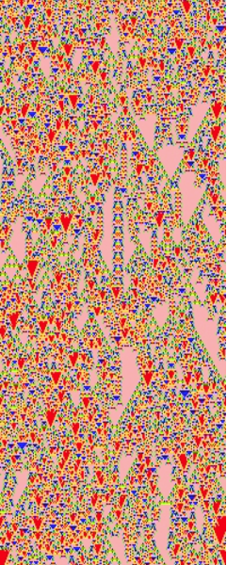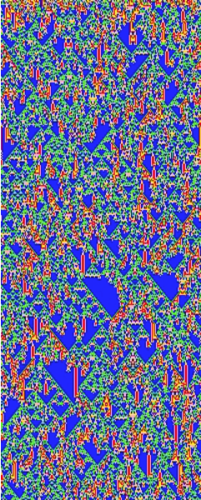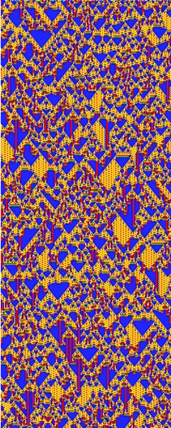

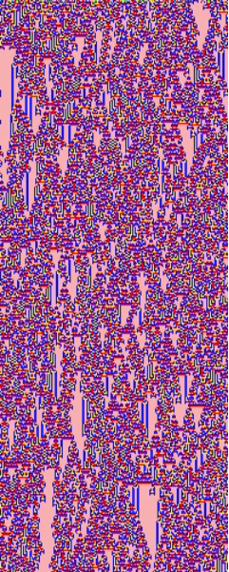

Pic. 12. Experiment 15 Step 0. Class IV

Pic. 14. Experiment 7 Step 6. Class IV

Pic. 11. Experiment 38. Step 3. Class IV

Pic. 12. Experiment 6 Step 3. Class IV

­

Pic. 12 definitely demonstrates high entropy because it literally has all states in play equally.

There were a few more obvious class IV images. Complex pattern was nowhere close to be a class II or III, but instead it was creating kind of a mixture of gliders and/or general aperiodicity from class III with mixed in periodic lines or spirals from class II, and also some homogeneous structures of class I were appearing randomly. Examples of such behaviors are demonstrated in Pic. 15 – 18.

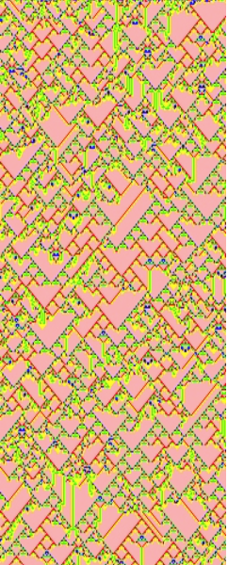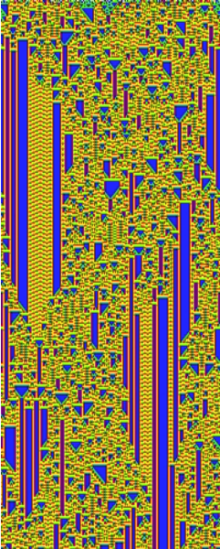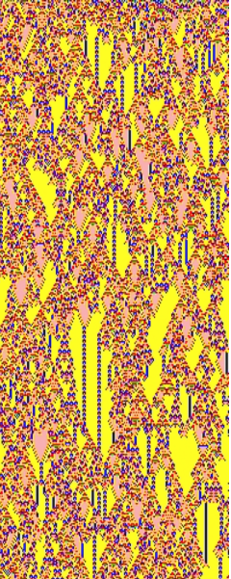

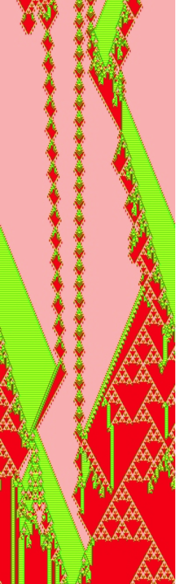

Pic. 18. Experiment 5. Step 2. Class IV

Pic. 17. Experiment 6. Step 0. Class IV

Pic. 15. Experiment 18. Step 2. Class IV

Pic. 16. Experiment 9. Step 4. Class IV

Last two of these examples also demonstrate high values of entropy, but it is also easy to see how colorful images are. First two also have high H values in a table (Pic. 10) but they are missing at least Blue(1) state, first one is having 2 out of 5 only. So entropy calculations are not quite accurate.

Standard deviation tells us the same from calculations of all 4 parameters in a table from Pic. 10. The smallest value is a deviation of totalistic lambda, that tells us that this parameter is the most accurate so far in predicting class IV behavior, since there is a least difference in $λ_{T}$ values for all class IV example, where other values are more discrete. So assumption here would be that behavior of class IV is likely dependent on sum of states in neighborhood cells.

Here is an interesting observation in Pic. 19,

Pic. 19. Number of occurrences of class IV at each step of experiments among all experiments

Class IV behavior is likely to be observed in steps 1-3 of an experiment, but most likely during step 2, meaning after 2 decimations. So, this observation should support the most efficiency of $λ_{T}$ out of all other parameters.

**Finally, let’s look at graphs (**better quality images are in excel worksheet**)**

In all graphs*, X axis demonstrates one of the parameters, Y axis is class value*, where 0 – classes I-II, 1 – class IV, 2 – class IV.

Lambda:

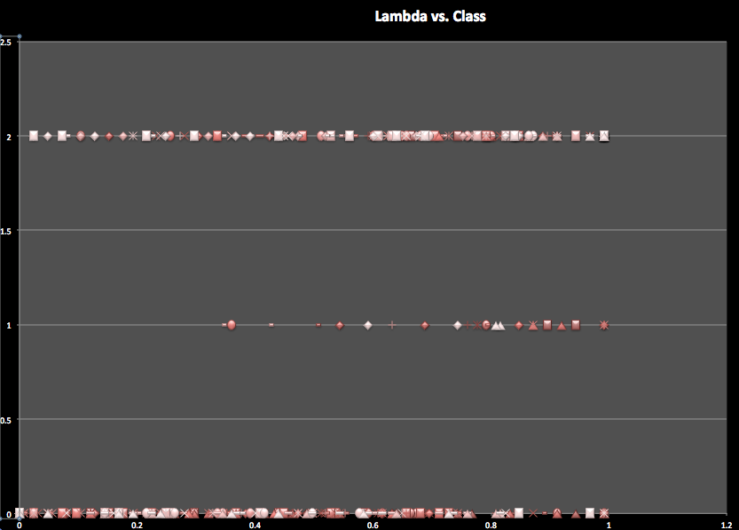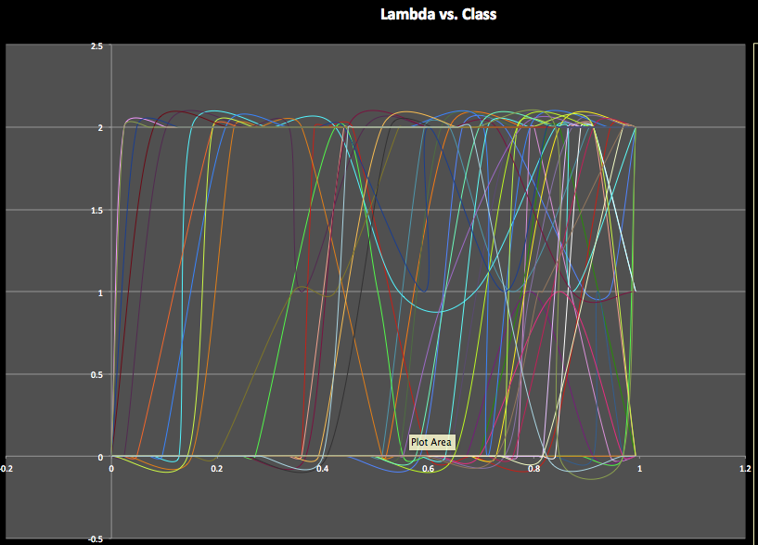

Pic. 20. Lambda VS. Class

Totalistic lambda:

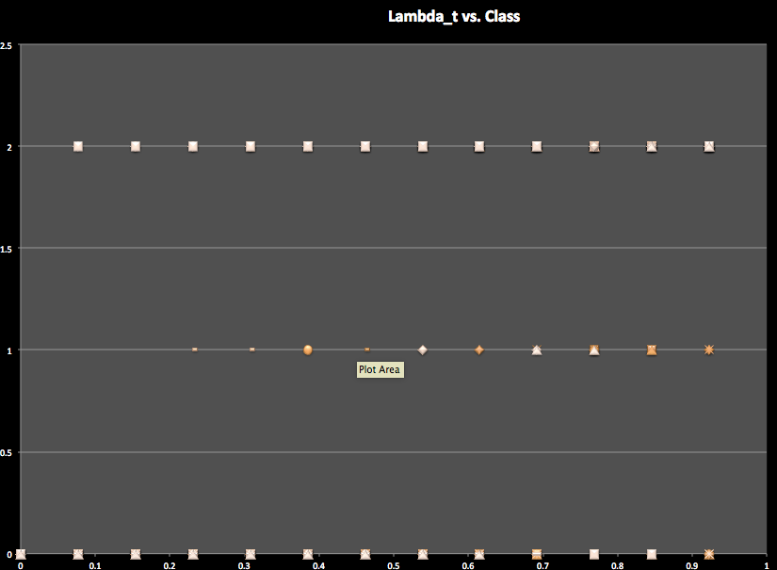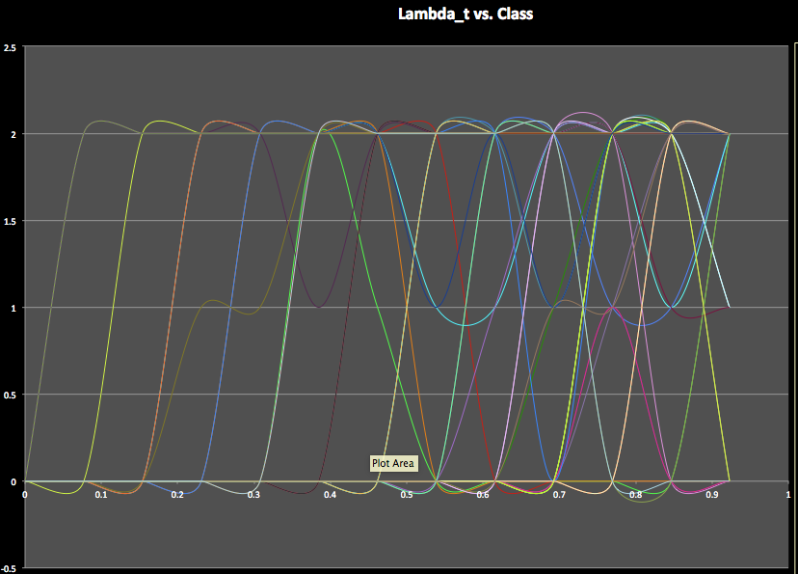

Pic. 21. Lambda _t VS. Class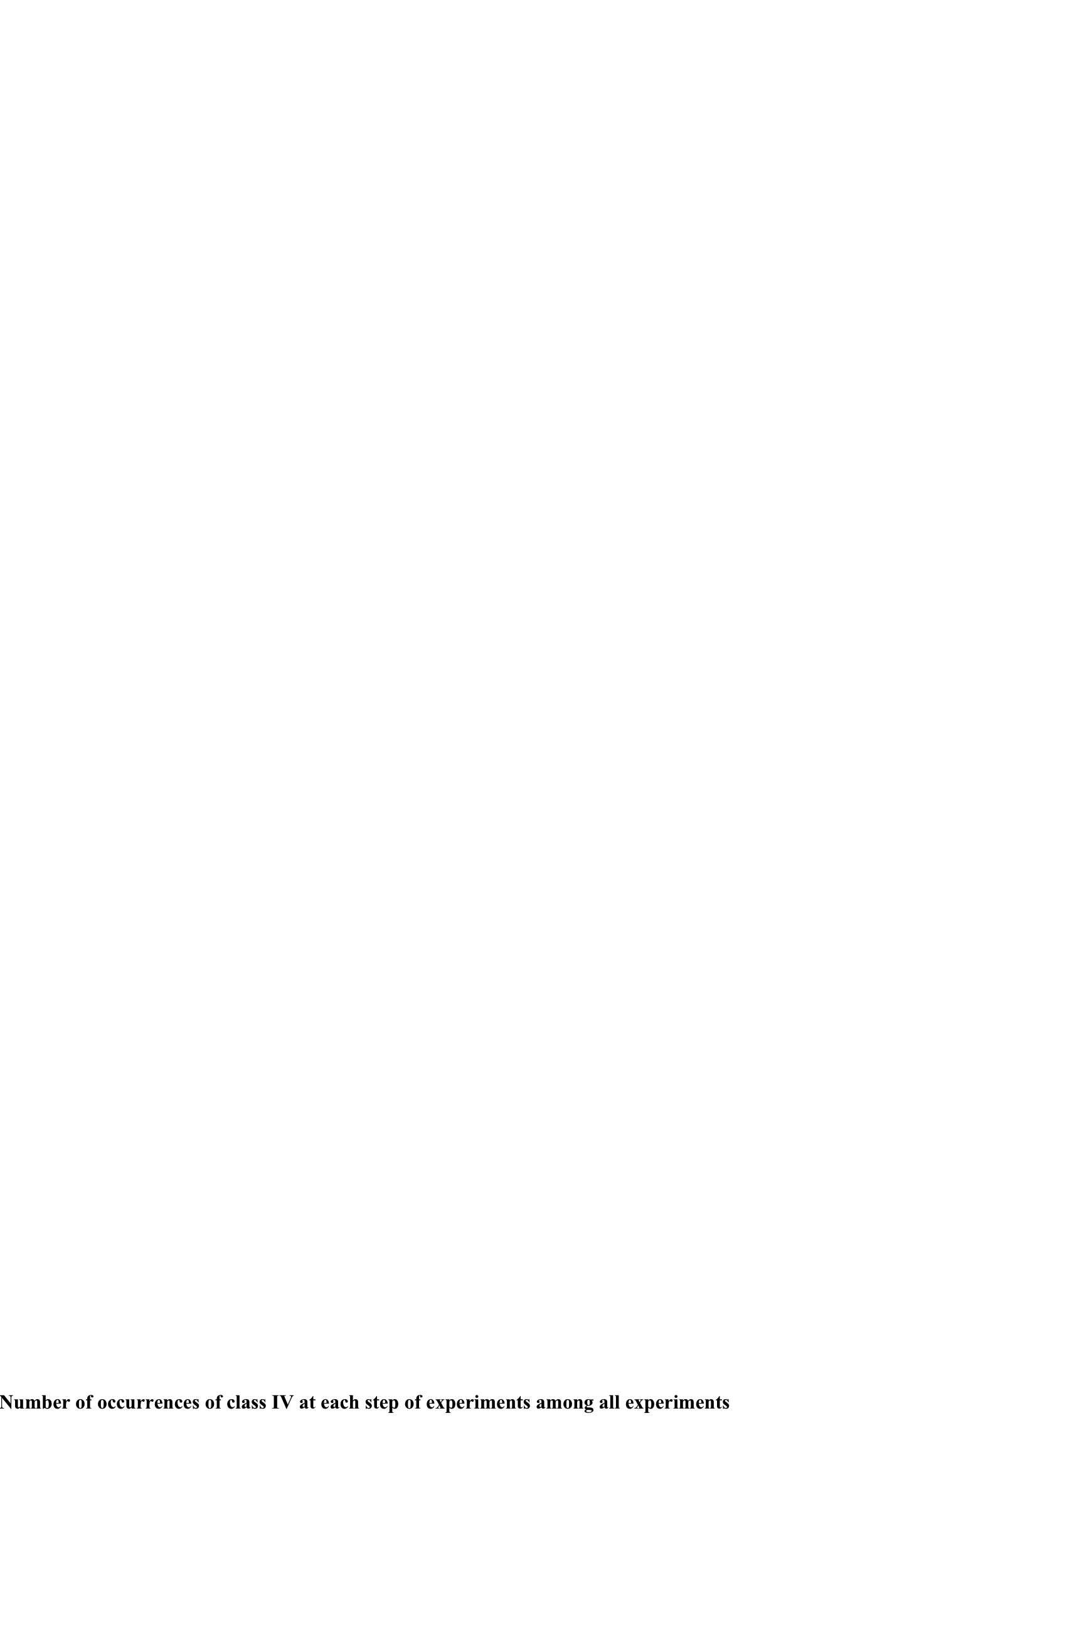 Class

Comparing these graphs (lined and dotted) in Pic. 20-21 for both lambdas, it is easy to see kind of constant behavior at lower value lambdas, ~0.1 – 0.3. That indicates that after a large number of decimations in a rule string CA will most likely behave constantly, going into quiescent state infinitely (class I). There were class II and class III examples at 11th step of decimation as well, dotted graph shows that the best. The behavior is slightly undefined towards the end of lambda in both lined graphs, especially in the first one (Pic. 20).

Pic. 20 shows still that class III is likely to happen towards the end of lambda, whereas class I is more clustered towards the beginning. These is some at the end too, but class II is also indicated as 0 on graphs. Class IV is clustered somewhere in between, but closer to the end, meaning that it has better chances to happen after a few (1-3) steps of decimation.

Totalistic lambda has a better defined graph that explains its better efficiency as well.

Entropy:

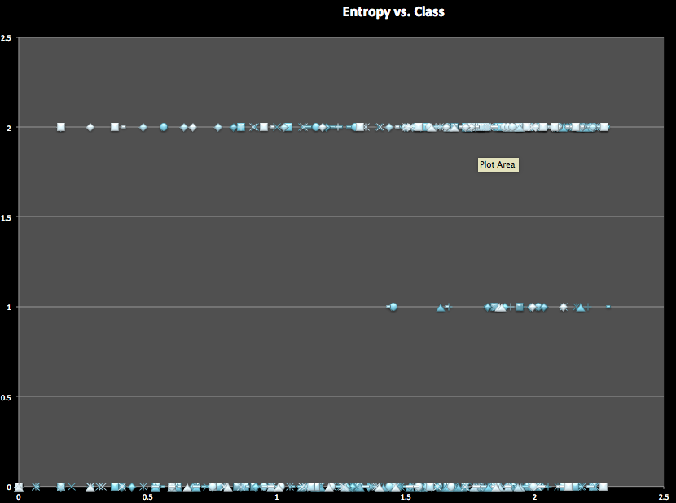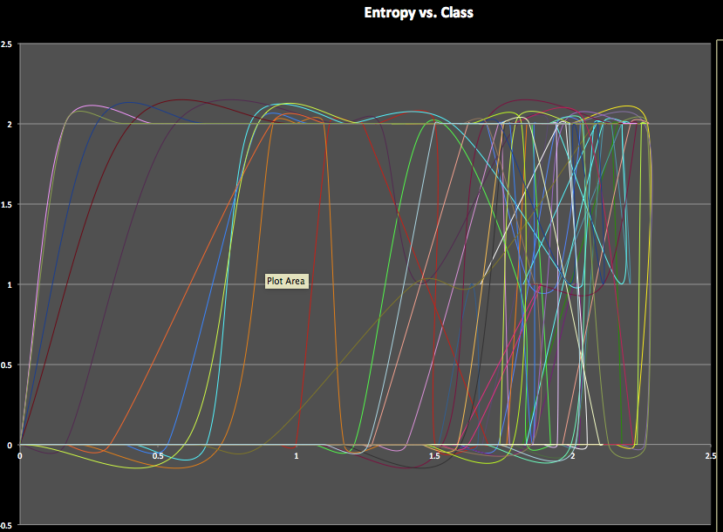

Pic. 22. Entropy VS. Class

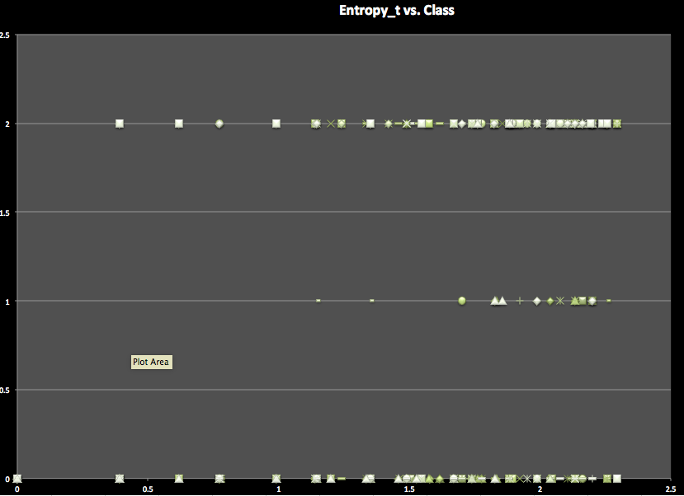Totalistic entropy:

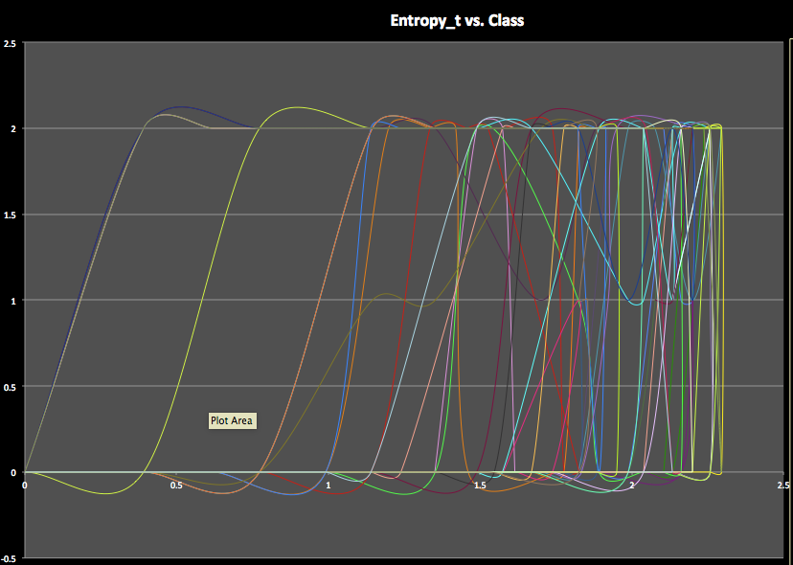

Pic. 23. Entropy_t VS. Class

Entropy should indicate an amount of disorder in CA. Totalistic graphs are more precise. Both graphs though in Pic. 22-23 indicate that the biggest disorder is likely to be in class III and IV. Class I-II also has high entropy values (mainly because of class II, for example Pic. 7), but it also covers the majority of lower values. So, no wonder why it is really hard to distinct class III and IV sometimes. All graphs also show, that class III has higher entropy than class IV. So this tells that some state(s) will dominate and some will be in minority or will not be there. So may be that’s where complex structure comes from, when class IV edges of from class’s III chaos.